2010, issue 2
Contents
Editorials Page 1
Research note: A possible Citizen’s Income scheme tested for labour market incentives Page 2
Obituary: Charlotte Markson Page 5
News Page 5
Conference report Page 6
Reviews: Page 7
Tony Salter, Andrew Bryans, Colin Redman and Martin Hewitt, 100 Years of State Pension: Learning from the Past
Mick Carpenter, Belinda Freda and Stuart Speeden (eds), Beyond the workfare state
Pat Devine, Andrew Pearmain and David Purdy (eds), Feelbad Britain: How to make it better
Irene Dingeldey and Heinz Rothgang (eds.), Governance of Welfare State Reform: A Cross National and Cross Sectoral Comparison of Policy and Politics
Tim Horton and James Gregory, The Solidarity Society: Why we can afford to end poverty, and how to do it with public support
Jane Millar (ed.), Understanding Social Security
Howard Glennerster, Understanding the Finance of Welfare
Orsolya Lelkes and Holly Sutherland (eds), Tax and Benefit Policies in the Enlarged Europe: Assessing the Impact with Microsimulation Models
Martin Evans and Lewis Williams, A Generation of Change, a Lifetime of Difference?
Martin Powell (ed.), Modernising the welfare state
Ed Wallis (ed.), From the Workhouse to Welfare: What Beatrice Webb’s 1909 Minority Report can teach us today
Kari Melby, Anna-Birte Ravn and Christina Carlsson Wetterberg (eds), Gender equality and welfare politics in Scandinavia
Viewpoint: Stumbling Backwards into the Future of Welfare, by Bill Jordan Page 15

Citizen’s Income Newsletter
ISSN 1464-7354
Citizen’s Income Trust
37 Becquerel Court, West Parkside, London SE10 0QQ
Tel: +44 (0) 20 8305 1222
Email: info@citizensincome.org
Website: www.citizensincome.org
Registered charity no. 328198
Director: Malcolm Torry
Disclaimer: Views expressed in this newsletter are not necessarily those of the Citizen’s Income Trust

Editorials
To the new Government: The ‘Big Society’
The Big Society is a society of personal autonomy: of choice over family structure, labour market activity, and much else. It is a society in which incentive translates into success and in which rights mean responsibility.
Small government is government which doesn’t interfere in people’s family structures, in their labour market activity, or in anything else much.
Our means-tested and complex tax and benefits system is riddled with rigidities and disincentives that deny us the choice which the Big Society promises; and it embodies the kind of interference in family structure and labour market behaviour which big government is all about. The coalition partners have said in their Programme for Government: ‘We will investigate how to simplify the benefit system in order to improve incentives to work’; and the Government’s consultation paper on the future of the benefits system, 21st Century Welfare (http://www.dwp.gov.uk/docs/21st-century-welfare.pdf), recommends a ‘Universal Credit’ as the way to do that:
The family’s gross entitlement would depend on their circumstances. Entitlements would be based on current benefit and Tax Credit rules, with amounts for individuals, couples, children, housing, disability or caring. The total would then be reduced for earnings and other income to produce the net amount payable. The credit would be payable to the household member making the application. …. Such a structure would remove much of the complexity that burdens the system today. Crucially it would also create the platform for tackling the current problems of high Marginal Deduction Rates and low gains to work through reform of earnings disregards and tapers. (p.19)
A Universal Credit would be a step in the right direction: but we suggest that the kind of major reform which the Big Society requires should encompass both the benefits and the income tax systems, because if tax allowances were changed from allowances to cash payments of the same value, and if only minor changes were made to the Universal Credit, then a Citizen’s Income would be the result: an unconditional, nonwithdrawable income for every citizen. Such a Citizen’s Income would provide all of the advantages of a Universal Credit along with substantial increases in simplicity and efficiency (particularly in relation to transitions between different labour market statuses); and, because a Citizen’s Income would take the individual and not the household as its basis, it would free both households and the employment market from significant rigidities and complexities. In terms of the Big Society agenda, a Citizen’s Income would incentivize enterprise, promote family structure and labour market choice, create the possibility of small government, and provide the foundation for the Big Society, in ways in which the Universal Credit would fail to do.
We look forward to working with the new Government on this important agenda, and as a first step would like to direct policy-makers to the research note in this edition of the Citizen’s Income Newsletter.
In the meantime: Please don’t means-test or tax Child Benefit. It’s the only benefit we’ve got which represents the Big Society.
Universal provision
Research by the Fabian Society and published by the Joseph Rowntree Foundation shows that people in this country are not particularly unhappy about the level of income inequality, often exhibit more negative attitudes towards those on low incomes than they do towards the rich, support progressive tax and benefits systems, wish to improve the life chances for disadvantaged citizens, understand the social consequences of income inequality, are not persuaded by arguments for greater equality, but are persuaded by ‘arguments for greater equality framed in terms of fairer rewards for effort and contribution’ (www.jrf.org.uk/publications/attitudes-economic-inequality)
A companion volume to the research published by the Fabian Society suggests that ‘as recent public outrage at attacks on the NHS have shown, it is the boldest, the most inclusive, and the most visionary policy solutions which command and retain the strongest popular support. Policy-makers concerned to secure greater economic justice have something to learn from that’ (Is Equality Fair? Ed. Tom Hampson and Jemima Olchawski, The Fabian Society, 2009, p.40).
Research which we publish here shows that a universalist social policy can provide people with a fairer return on their effort in the labour market. Here is a policy which answers precisely to the two attitudinal criteria.

Research note
A possible Citizen’s Income scheme tested for labour market incentives
On the 27th January the House of Commons Work and Pensions Committee published a report, Decision making and appeals in the benefits system (HC313, available at www.publications.parliament.uk/pa/cm200910/cmselect/cmworpen/313/313.pdf )
The last two paragraphs read as follows (bold type in the original):
We do not underestimate the difficulty of the task facing decision makers across DWP’s businesses. The complex rules that govern the social security system increase the scope for both customer and official error and the challenge of decision making accuracy. We have previously recommended that the Department establish a body to examine complexity in the benefits system and this has been supported by a number of organisations, including Citizens Advice.
We reiterate a previous recommendation of this Committee, that the Government should establish a Welfare Commission to examine the existing benefits system and model possible alternative structures with the aim of creating a fair but simpler system that claimants and their representatives are able to understand more easily and DWP staff are able to administer more accurately (our italics)
But of course it isn’t just the DWP’s section of the benefits system which is too complex: it is also Tax Credits, administered by HMRC, which complicate the financial affairs of large numbers of working households.
We wanted to test whether it is possible to revise the tax and benefits system in such a way as
- to increase employment incentives and make nobody worse off for household gross earnings up to £750 per week for families with children and up to £450 per week for single adults without children;
- to reduce administrative complexity considerably by scrapping Working Tax Credits and Child Tax Credits
- and to do by it making as few other changes as possible to the current system.

The method:
We took three family types:
- Single adult, no children, local authority tenant (working 40 hours per week)
- Lone parent, two children under 11, local authority tenant (working 16 hours per week)
- Couple, with two children under 11, private tenant (working 40 hours per week)
We have used the spreadsheet employed by the Department for Work and Pensions to construct their Tax Benefit Model tables to calculate net incomes after housing costs for gross earnings between £20 and £1,200 per week for a variety of schemes for each of the household types a) to c) and have compared those net incomes with net incomes under the current system. The housing costs assumed in these calculations are £58 for household a), £69 for household b), and £138 for household c).
The scheme which provides the closest fit with the criteria 1) to 3) above is as follows:
We have scrapped Working Tax Credits and Child Tax Credits and replaced them with Citizen’s Incomes of £60 pw for each adult and £31.59 pw for each child (effectively an increase in Child Benefit of £31.59 p.w.). (A Citizen’s Income is an unconditional, nonwithdrawable income paid to each individual as a right of citizenship)
Income tax is collected on all earned income as follows:
From £0 to £20,000 pa, 20%
From £20,001 to £40,000 pa, 35%
Above £40,000 pa, 40%
We have removed the Lower Earnings Limit for National Insurance Contributions, and also the Upper Earnings Limit (but see below). This means that National Insurance Contributions as well as Income Tax is charged on all earned income, not just on that above the Lower Earnings Limit).
We have reduced the Housing Benefit taper from 65% to 40%
The graphs show the results. The steeper curve resulting from the revised scheme indicates higher employment incentives, particularly for the couple with children.
(Note that because this project is only about households containing wage-earners working specified numbers of hours and a National Minimum Wage is paid, the first £232 of the gross earnings range can be ignored in the case of the couple and the single adult, and the first £93 for the lone parent.)
All three graphs show net income under the revised system diverging from net income under the current system as gross earnings rise towards the right hand side of each graph. This is because for the purpose of the project we have removed the National Insurance Contribution Upper Earnings Limit so 11% National Insurance Contributions are now paid on all earned income.
A political decision will be required to determine whether and where a new Upper Earnings Limit should be established. If there is no Upper Earnings Limit then the revised scheme will save money. If a low Upper Earnings Limit were to be established then the scheme would cost money. Somewhere along the gross earnings range there will be an Upper Earnings Limit which will enable the revised scheme to break even.
The Chancellor will therefore have available a simple mechanism for regulating the cost of the scheme.
Conclusion
By replacing tax credits with a Citizen’s Income, and by making a few other minor changes, the tax and benefits system can be amended to increase employment incentives across substantial earnings ranges for a variety of household types.
We hope that by offering this indicative scheme we shall encourage research into further options: into their effects on net income for different family types; into their consequences for labour market behaviour; and into their redistributive characteristics. The scheme studied here increases substantially the net income of employed couples with children across part of the income range, so either additional funding would be required (somewhat unlikely in the current economic climate) or significant redistribution would need to be acceptable. There might be feasible schemes which would offer the virtues of the scheme discussed here at the same time as increasing net income for all house-hold types by lower amounts, and there might be feas-ible schemes which would fulfil our criteria and which would save money. Such schemes would clearly be of interest to a Government attempting to reduce costs.
What is now required is a great deal more research on different household types and on a wide variety of different Citizen’s Income schemes. Of particular interest would be the net income effects on non-earning households as they make the transition from unemployment into part-time or full-time employment.
The graphs:

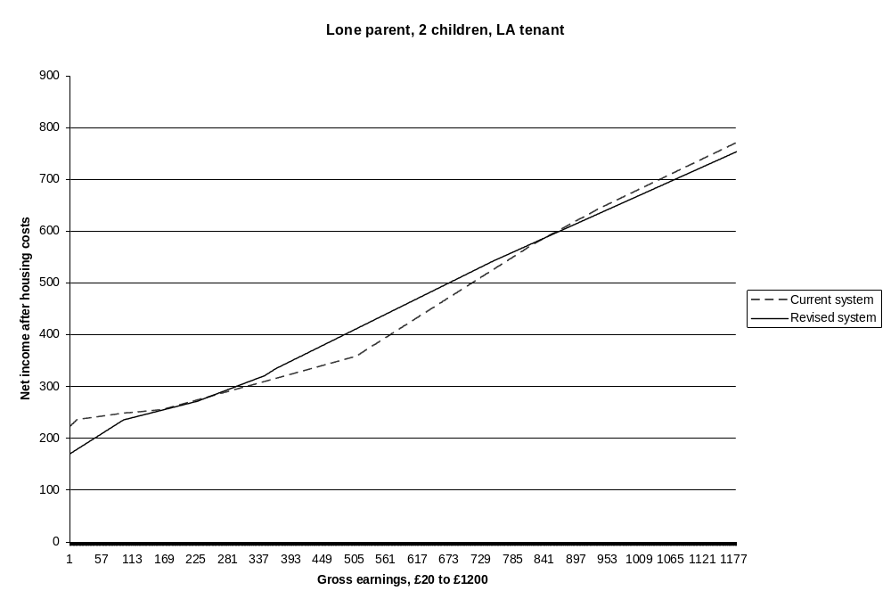

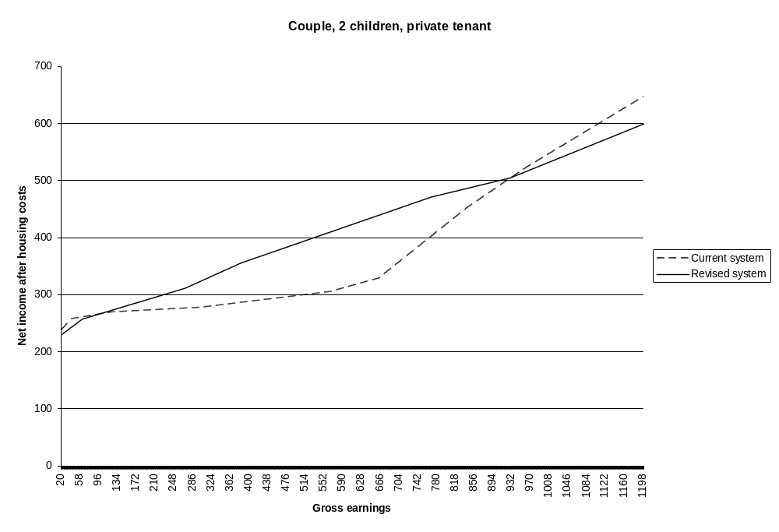

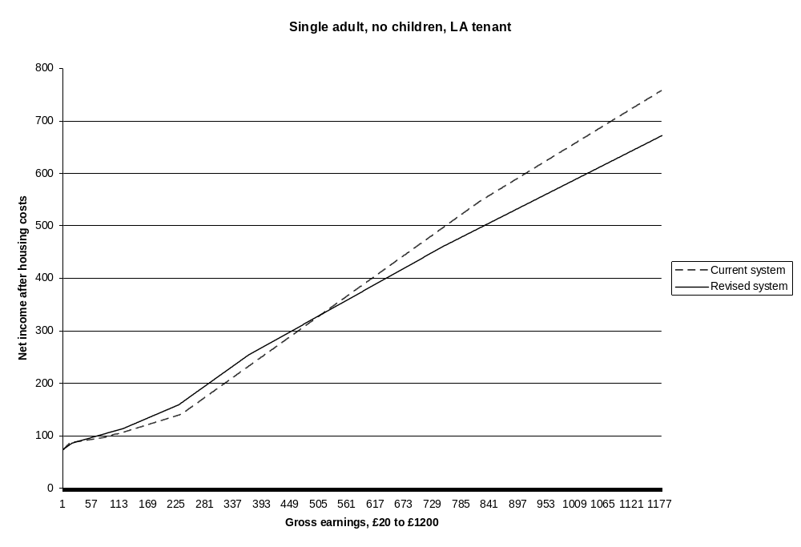

We are grateful to the Department for Work and Pensions for providing us with the spreadsheet which they use to calculate their Tax Benefit Model Tables (http://statistics.dwp.gov.uk/asd/asd1/tbm/TBMT_2009.pdf)

Obituary
Charlotte Markson, a Citizen’s Income Trust trustee since 2006 and often a source of valuable advice before that, died on the 31st July after a long battle with leukemia.
Charlotte worked for Citizen’s Advice, the national organization which, among other services, provides the summaries of legislation and regulations on which Citizen’s Advice Bureau workers rely when they advise members of the public. She was one of the few people who understood the tax and benefits system, both in its structure and in its detail, and we shall sorely miss her expertise.
Charlotte will be missed far more by her partner Geoffrey, and by her mother and brother, and we extend to them our heartfelt condolences.
News
The Prime Minister has appointed Frank Field, a former Labour minister, to chair a Review on Poverty and Life Chances. Mr. Field writes in the Daily Telegraph (5th June): ‘There is … a pressing need to rethink our approach to poverty, and to the state. … If the review is successful, the debate over poverty will give way to a dynamic approach that looks at how we ensure that each individual is able to achieve their best self.
The National Association of Pension Funds has suggested that a ‘new state Foundation Pension should be created, combining the current basic state pension and state second pension. This would be worth £8,000 a year, around a third of pre-retirement income for someone on median earnings. It would give pensioners an additional £25 a week in income and take around 2 million pensioners out of means testing. It would provide a solid floor on which to provide workplace pensions’. (www.napf.co.uk)
In recent research reported in Social Policy and Administration Peter Taylor-Gooby and Rose Martin show that in Germany and the UK different social security regimes result in real differences in perception: ‘the analysis shows that while respondents in both countries value equality of opportunity as a normative principle, those in Germany are much more likely to argue that an equal opportunity approach requires government to guarantee equal access to basic services. They are also more likely to express concerns about market freedoms which allow those who can afford it better access to health care and education. Real differences in welfare values remain, loosely following differences of regime type, despite the greater emphasis on activation and individual responsibility across European welfare states.’ (Peter Taylor-Gooby and Rose Martin, ‘Fairness, Equality and Legitimacy: A Qualitative Comparative Study of Germany and the UK’, Social Policy and Administration, vol.44, no.1, February 2010, pp.85-103)
Senator Eduardo Suplicy of Brazil reports that the Partido dos Trabalhadores (PT) held its fourth National Congress in February and that delegates unanimously approved the following as part of the Presidential Program of Mrs. Dilma Rousseff who was acclaimed the PT’s Presidential candidate in 2010: ‘... transition from the Bolsa Família Program to the Citizen´s Basic Income – CBI, unconditional, as a right of everyone to participate in the wealth of the nation, as foreseen in Law 10.853/2004, an initiative by PT, approved by all parties of the National Congress and sanctioned by President Luiz Inácio Lula da Silva on January 8th, 2004’.
In its Socio-Economic Review for 2010: An Agenda for a new Ireland – Policies to ensure economic development, social equity, and sustainability, the think tank Social Justice Ireland offers ten reasons for implementing a Citizen’s Income: ‘It is work and employment friendly; it eliminates poverty traps and unemployment traps; it promotes equity and ensures that everyone receives at least the poverty level of income; it spreads the burden of taxation more equitably; it treats men and women equally; it is simple and transparent; it is efficient in labour-market terms; it rewards types of work in the social economy that the market economy often ignores, e.g. home duties, caring, etc.; it facilitates further education and training in the labour force; it faces up to the changes in the global economy.’ The report recommends that the Irish Government should move towards introducing a basic income system. All initiatives in the areas of income and work should constitute positive moves towards the introduction of a full basic income guarantee system.’ (http://www.socialjustice.ie/content/agenda-new-ireland-full-text)

Conference report
Montreal Conference a BIG Success
By Jim Mulvale, BIEN Canada
On the 15th and 16th April a conference was held in Montréal, Quebec, entitled Basic Income at a Time of Economic Upheaval: A Path to Justice and Stability? The event was organized by the Centre de Recherche en Éthique de l’Université de Montréal (CREUM), in cooperation with BIEN Canada and the USBIG Network. The event attracted almost a hundred participants from North America and Europe, including a number of people who had not previously attended Basic Income conferences or meetings.
The highlights of the conference included presentations by Dr. Louise Haagh of the University of York (UK) on ‘Basic Income and Public Finance’, by Dr. Guy Standing, University of Bath, on ‘Basic Income for the Precariat’, and by Senator Eduardo Suplicy (São Paulo, Brazil) on ‘Steps Towards a Citizen’s Basic Income’.
A ‘political panel’ featured speakers from Quebec, Canada and the United States who focused on political openings and challenges for achieving BI in North America. The panel consisted of Amélie Chateauneuf, spokesperson for the Front Commun des Personnes Assistées Sociales du Québec (FCPASQ); Tony Martin, Member of Parliament and poverty critic for the New Democratic Party; Rob Rainer, Executive Director for Canada Without Poverty; Al Sheahen, long-time activist with USBIG; and Canadian Senator Hugh Segal. The panel was chaired by Sheila Regehr, Director of the National Council of Welfare of Canada.
Other sessions at the conference addressed Education for a BIG Society (Sally Lerner), Pragmatic Guaranteed Income Architecture for Canada (Rob Rainer and Jim Mulvale), Exporting the Alaska Model (Karl Widerquist), the Ecological Imperative for a BIG (Anita Vaillancourt, Gianne Broughton, and Michael Howard), Economic Crisis and Income Security (Chandra Pasma, James Bryan, and Philip Harvey), Basic Income funded through Common Assets (Gary Flomenhoft), Basic Income and Consumption Tax (André Presse), and Geonomics (Jeffrey Smith).
A pre-conference workshop was also held, which featured three excellent presentations:
- Sandra Gonzalez-Bailon, University of Oxford, ‘Labour Behavior, Basic Income and Social Influence: A Simulation Experiment’
- Evelyn Forget, University of Manitoba, ‘Canada’s Experiment with Social Justice: Using health Administration Data to Assess the Outcomes of a BI Field Experiment’ (based on the Mincome Project that ran Dauphin, Manitoba in the 1970s)
- Guy Standing, University of Bath, ‘Basic Income Pilot Schemes: Ten Imperatives for Design and Evaluation’
Full details of the program can be found at http://bigmontreal.wordpress.com/
Papers from the conference will be posted on the website of USBIG in the near future:
http://www.usbig.net/
A huge vote of thanks goes to Jürgen DeWispelaere, currently a Senior Research Fellow at CREUM (and also Co-Editor of Basic Income Studies) who took the lead role in planning and organizing this conference. Thanks also go to Jürgen’s colleagues at CREUM for financial, practical and logistical support for this event.
BIEN Canada and USBIG are planning future joint events, building on the strong interest in, and excellent programme of, this conference in Montreal.
Reviews
Tony Salter, Andrew Bryans, Colin Redman and Martin Hewitt, 100 Years of State Pension: Learning from the Past, Institute of Actuaries, 2009, vi + 266 pp, pbk 1 903 965160 , £16.95
2008 was the centenary of the Old Age Pension Act 1908, which established the first state pension: an income-tested non-contributory pension for everyone aged over 70. The Institute of Actuaries and Tony Salter and his colleagues are to be congratulated on a book which celebrates that centenary and which more than fulfils the promise of its title.
The history of state pensions is recounted: the failure of the Poor Law of 1601 and the Poor Law Amendment Act of 1834 to relieve old age poverty; Lloyd George’s 1908 Old Age Pension Act; the growth of contributory pensions for various groups between the wars; Beveridge’s report and the National Insurance Act 1946; the persistence of means-tested pensions in a context of low national insurance pensions; earnings-related contributory state pensions; contracting out of the earnings related pension; the equalisation of state pension ages; winter fuel payments; and the Minimum Income Guarantee and the Pension Credit. The chapters are full of historical and financial detail, and the discussion of state pensions takes place where appropriate in the context of discussion of occupational and private pension provision.
Chapter 12 is entitled ‘Learning from the Past’ and sets out from the important statistic that the current basic state pension is worth less today as a percentage of average earnings than it was when the first old age state pension at 5s (25p) per week was paid to the first pensioners on the 1st January 1909. It also sets out from the question as to the extent to which it is the state’s role to ensure adequate social pension provision for the elderly (p.173).
The authors express concern that 40% of current pensioners could qualify for the means-tested Pension Credit, that this percentage could increase, and that up to 1.8m pensioners who could claim Pension Credit don’t do so because of ‘the complexity of the claiming process and the stigma associated with being dependent on state benefit’ (p.178). As for current rates, the basic state contributory pension provides an income of below 16% of average earnings (p.178). The authors are also disturbed by the increasing income gap between pensioners with private pensions funded by contributions on which tax relief has been granted, and pensioners reliant on means-tested Pension Credit. To provide a universal pension at the same rate as the threshold for means-testing would cost only one third of the cost of tax relief on private pension contributions.
The authors believe that ‘the basic state pension ….. should continue to be the bedrock of pension policy’ (p.183) and they discuss the feasibility of providing a universal basic state pension. Such a universal and unconditional pension would mean that pensioners would retain the benefit of their savings, thus making it more likely that people would pay for private pensions.
The book closes with some helpful outlines of the main legislation on state pension provision since 1908, a history of the National Insurance Fund (with income and expenditure accounts from 1949 to 2008 and projections to 2013), a profile of William Beveridge, Great Britain population profiles from 1901 to 2001 (and estimates to 2081), statistics on life expectancy and income distribution, and a good index.
This book is essential reading for anyone interested in the history and possible futures of the state pension in the UK. If policy-makers were to take its lessons to heart then perhaps the next time a Pensions Commission recommends careful study of a Citizen’s Pension (as the Pensions Commission did in 2005) there might be more chance of government ministers understanding why that would be a good idea.
Mick Carpenter, Belinda Freda and Stuart Speeden (eds), Beyond the workfare state, Policy Press, 2007, viii + 192 pp, pbk, 1 861 348722, £19.99, hbk 1 861 348739, £60
Part I of this evidence-based approach to labour market exclusion reports on case studies in labour market discrimination and inequalities. As we read these reports of qualitative and quantitative research amongst discriminated-against groups and in disadvantaged communities, a consistent message emerges: active labour market projects simply designed to get people into employment as quickly as possible serve neither the economy nor clients’ long term interests. What’s needed are better entry-level jobs and solutions to structural inequality and discrimination in employment. Transition-focused approaches lead to just that: brief transitions into the labour market. A broader approach which promotes individuals’ autonomy and capabilities, which values their ability and right to make decisions as to whether to enter the labour market and if so how, and which removes disincentives to labour market entry, is recommended.
In part II some detail is added to the prescription. First comes a history of New Labour policy. In the early years, enhanced childcare provision, tax credits, and a fairly gentle ‘active labour market’ approach, along with improvement in economic conditions, led to a fall in unemployment. Then the fall slackened, and deindustrialised areas in particular continued to record high unemployment rates. Then sanctions increased and a target-driven approach experienced diminishing returns and a substantial transfer of claimants from Jobseekers' Allowance to Incapacity Benefit.
The final chapter outlines a ‘capabilities and human rights approach’. ‘Capabilities’ are human ‘functionings’ within and outside the formal labour market, and they include what people value doing; and the rights relate to the provision of well-rewarded good work, to greater equality, and to a better work-life balance.
When you read this book you should start with chapter 2 and read chapter 1 last. Chapter 1 is called an ‘introduction’ but actually it's the ‘conclusions’ chapter. It really ought to have been at the end of the book.
The editors conclude that a top-down welfare-to-work regime exhibits diminishing returns, but that the type of employment reintegration which works is characterised by local discretion, flexibility, the ability to work outside bureaucratic structures, and ‘a voluntary rather than a sanction-based relationship between project workers and service users in which power to act fundamentally rested with the latter’ (p,4). Such an alternative approach is particularly needed for people for whom short-term skills enhancement currently leads to insecure low-skill employment which offers little economic improvement compared to a life on benefits.
The editors find a significant contradiction at the heart of workfare approaches: ‘External surveillance and sanctions, and encouragement to internal motivation and effort’ (p,5). Their view is that ‘genuine empowerment can only come from freely exercised choice, and .... this .... is the only realistic and socially just way of tackling labour market exclusion’ (p.6). They ask for a ‘human capital’ approach which addresses such problems as benefit traps. This is the way to improve excluded groups’ relationship with the labour market, not sanctions. According to the evidence, a capabilities and human rights approach works.
A Citizen’s Income gets a mention, but only as a possibility of freedom from the labour market which might lead to the meeting of community needs (p. 165). A Citizen's Income would also, of course, address one of the barriers to a capabilities and human rights approach: benefit traps. By reducing marginal deduction rates a Citizen’s Income would make employment pay, and it would make it more feasible for people to decline low-wage poor-quality employment, thus improving employment, increasing low wages, and ensuring that net incomes would increase as earned income rose.
This book contains important evidence and relevant conclusions, and everyone interested in labour market participation should read it.

Pat Devine, Andrew Pearmain and David Purdy (eds), Feelbad Britain: How to make it better, Lawrence and Wishart, 2009, 250 pp, pbk 1 905 007936, £14.99
‘The struggle to replace neoliberalism, at national and global levels, is what the politics of the next ten years will be about, just as the Great Crash of 1929 and the Great Depression that followed it prompted an urgent search for workable alternatives to the discredited economics of laissez faire’ (p.8).
The authors recognise that after so many years of a neoliberal New Labour it will take a long time for the democratic left to turn itself into a political force. This book is designed as a first step in the direction of that important task.
Chapter 1 outlines our current economic, social and political crisis. The dominant theme under both Conservative and New Labour governments has been ‘the deliberate extension of market forces into all aspects of social life’ (p.24), and the authors outline the ‘social malaise’ which has been the result. Two of the subheadings say it all: ‘New Labour: Consumer Thatcherism’ (p.54) and ‘What on earth is to be done?’ (p.63). The editors’ answer is ‘a sustainable post-capitalist world’ (p.65) which takes the danger of climate change seriously and is characterised by a combination of ‘social equality and human solidarity’ and by ‘positive freedom and democratic self-government’ (p.66).
In relation to the need to restrain growth in a context of resource depletion the editors recommend the dismantling of the current work-income nexus and a Citizen’s Income as a means of achieving that.
Subsequent chapters unpack the ideas outlined in chapter 1: Citizen’s Income, social ownership and democratic planning, a work-life balance tilted more towards time for collective, private and public activities, a renewed democracy, the NHS, schools as places of genuine education, and reducing the demand for energy (which is consistent with a post-consumerist work-life balance). All of the detailed chapters, except for that on the NHS, recommend practical policy aimed at the new kind of society envisaged by the first chapter.
In the closing chapters Antonio Gramsci’s Prison Notebooks inspire a call for real political debate (as opposed to the current ‘ephemeral quarrels and personal clashes’). The undermining of the feminist critique by a superficial empowerment of women is lamented, hope is located in the broad left agenda of many card-carrying Greens (p.233), and David Purdy wonders whether left-leaning elements both inside and outside mainstream political parties might be able to work together to create a new political landscape.
It’s a pity that the book has neither index nor bibliography, and, more importantly, no contribution from Compass or the Fabian Society. However, the authors are to be congratulated on creating a coherent theoretical and practical platform which will inform the political debate that we need to have in this new era of coalition government.
Irene Dingeldey and Heinz Rothgang (eds.), Governance of Welfare State Reform: A Cross National and Cross Sectoral Comparison of Policy and Politics, Edward Elgar, 2009, vi + 263 pp, hbk 1 84720 143 0, £65
The editors of this diverse and interesting collection of essays have focused on three questions:
- ‘How are policies and regulatory structures changing?’
- ‘How are the reform processes in different policy areas or countries being shaped?’
- ‘Are there signs of convergence or divergence across different welfare state types?’ (pp.1,2)
All three questions are about ‘governance’, which the editors take to mean ‘all existing forms of collective regulation of societal matters, from those based on the state to those based solely on civil society’, thus encompassing both the structures of the system and the processes by which activity is regulated and controlled.
Rothgang (ch.2) finds increasing complexity in healthcare systems in Britain, Germany and the USA. The basic characters of the different systems haven’t changed, but increasing diversity within each system is leading all of them towards greater hybridity. Hippe (ch.3) finds a similar process occurring in pension provision, thus supporting ‘the hybridisation hypothesis, which predicts convergence towards mixed regulatory frameworks based on market mechanisms that stress individual responsibility as well towards social policy structures that promote collective responsibility’ (p.64). Dingeldey (ch.4) finds that the promotion of employability is central to the labour market policies of Denmark, the UK and Germany, and that therefore state intervention in this field is increasing rather than decreasing. Martens and Jakobi (ch.5) study the OECD’s contribution to the formation of education policy in its member countries and conclude that the organisation’s impact is now considerable, and they take this finding as an indicator of the growing influence of such international organisations. Starke and Obinger (ch.6) find that, in many of the same countries, welfare states are converging in relation to a number of indicators: not in a ‘race to the bottom’, as some have suggested, but more often in an ‘upwards’ convergence.
Thus the first section of the book employs research on particular policy areas in order to understand general trends. The second part reverses the process, and asks about the impact of the processes identified on particular policy areas: health, pensions, the labour market, and education.
An interesting point about Gerlinger’s discussion of changes in health insurance systems in Germany, Switzerland and the Netherlands (ch.7) is that the UK couldn’t have been compared in the same way because the universal NHS avoids the need for state regulation of health care insurance. It might have been worth mentioning this. Bonoli’s chapter (ch.8) on trade union involvement in pension reform in Sweden, France, Switzerland, Italy and Germany contains an important lesson for policy-makers: that system change requires deep involvement by such stakeholders. In chapter 9 Cox studies labour market reform in a variety of countries and finds that, where new ideas have been persuasively championed by political parties, coherent reform has taken place; but that where political parties have resisted change, the outcome has been policy drift. In this latter case the result will be that the inevitable adjustment to new ideas will lead to more public discord than it might otherwise have done. Klitgaard finds that greater knowledge of other countries’ educational policies and their outcomes is causing considerable convergence between different countries’ education policies.
The editors offer a final concluding chapter which draws together the conclusions of the different chapters into a picture of continuing diversity within which a few trends are identifiable, and in particular ‘a withdrawal of the state from service provision and a simultaneous extension of the state’s responsibilities for guaranteeing the delivery of an access to services’ (p.250).
We draw another conclusion. A five page discussion of the Netherlands pension system (pp.52-7) gives four lines to the residence-based flat-rate Citizen’s Pension and five pages to the funded industry-based sector. The internal governance of Britain’s NHS is discussed but not its universal provision, which really ought to have been compared with insurance-based healthcare systems. The UK’s Child Benefit doesn’t get a mention, even where it would have been highly relevant (e.g., pp.75-7). The editors and authors clearly regard universal provision as not worth discussing, yet it has been a highly successful welfare system in its own right. It has low administrative costs, it doesn’t contribute to labour market inflexibilities and disincentives, and it doesn’t disincentivise saving for old age. So here is a hypothesis: Universal provision is so successful when implemented that it creates no problems. It is problems, not successes, which demand the attention of policymakers and academics, so universal provision drops off the policy agenda and therefore isn’t considered as an option when welfare reform options are discussed.
We would be interested to hear our readers’ responses to this hypothesis, and suggestions as to how we might solve the dilemma.
Tim Horton and James Gregory, The Solidarity Society: Why we can afford to end poverty, and how to do it with public support, The Fabian Society, 2009, xxxiii + 271 pp, pbk 0 716 341109, £12.95
This splendid result of a research project inspired by the centenary of Beatrice Webb’s Minority Report of the Royal Commission on the Poor Law will be of inestimable value to the new Government.
The first chapter shows how institutional detail affects public attitudes to poverty prevention and thus the extent to which poverty can be prevented; chapter 2 discusses the challenges facing policy-makers (particularly an ageing population) and shows that what is required is a new poverty prevention strategy designed to achieve public support; and chapter 3 offers lessons from the past sixty years: the universal NHS remains popular, targeted social housing isn’t, and the NHS serves poverty reduction far more successfully than social housing does. The authors show that benefits policy has shifted towards means-testing and thus towards negative public assessment of people receiving benefits.
Chapter 4 shows how targeting on the poor means that, in the longer term, poor people actually receive less, and that, paradoxically, allocating on the basis of need isn’t the best way to help people in need. Preventing poverty ‘is not about how we spend our next pound bringing about the largest possible reduction in poverty, but rather about getting the underlying institutional design right’ (p.98, their italics). If the design is wrong, then the evolutionary path will be wrong, and only a redesign of the system can correct that.
Chapter 5 offers the results of research on public attitudes to welfare provision, and chapter 6 takes the lessons learnt during that and previous chapters and recommends universalism and integration as the guiding principles for welfare system design. In the housing field the authors recommend full dispersal and integration of social housing, bringing housing assistance into a single system, and a spectrum of funding methods between ownership and non-ownership.
For tax and benefits they recommend turning tax allowances into a flat-rate tax credit and then making it payable to all, thus creating a Citizen’s Income (which the authors call a Basic Income). It is the third step in their plan which then poses a problem, for they recommend that the credit be paid on a household basis (p.163). This was suggested by Steven Webb in Samuel Britten and Steven Webb, Beyond the Welfare State: An Examination of Basic Incomes in a Market Economy (David Hume Institute, 1990). It was a mistake then, and it would be a mistake now. Quite apart from the fact that a household basis would lose the administrative simplicity of a Citizen’s Income paid to each individual, we know that people prefer income tax to be calculated on the basis of the individual and so Horton and Gregory’s own criterion of public acceptability requires an individual-based Citizen’s Income and prohibits a household tax credit. In addition, the household’s employment pattern choices would be improved by an individual-based Citizen’s Income, so in this respect too an individual-based Citizen’s Income would prevent poverty more effectively than a household benefit. Any government which decides to implement the report’s suggestions therefore needs to stop at the individualised Citizen’s Income and not transfer it to a household basis.
Similarly, the authors’ suggestion of a participation income also needs to be resisted. The casework approach required by this policy would render it socially unacceptable, which on its own would suggest that the authors ought to have resisted the idea. Also, the money saved by refusing the benefit to a tiny proportion of the population would be far less than the additional administrative costs of monitoring everyone. The authors correctly recognise the NHS to be a primary model for welfare policy because its unconditionality results in positive public assessment of those it serves and of the service itself. The same would be true of a Citizen’s Income, and for the same reason.
The report’s final chapter asks for a new welfare contract based on reciprocity. Here again, the authors haven’t quite learnt their own lessons. If the NHS is the public’s favourite part of the welfare state ( - and Child Benefit would, I suspect, run it a close second, or even beat it into first place), then it is universality, and not reciprocity, which generates public approval and so ought to be the basis of any new welfare contract.
It is certainly time for a redesign, and this report contains everything necessary for doing that. Now we need a second edition which doesn’t draw back from the lessons learnt during the first few chapters. The evidence points towards a welfare state founded on universal provision, with reciprocity a consequence of universality and not as the system’s hallmark. The evidence points towards a Citizen’s Income: universal, unconditional, and paid to each individual – not to households.
Whilst flawed, this report is a fine piece of work, and the authors are to be congratulated.
Jane Millar (ed.), Understanding Social Security, 2nd edition, Policy Press, 2009, xxii + 322 pp, pbk, 1 847 421869, £21.99, hbk 1 847 421876, £65
Howard Glennerster, Understanding the Finance of Welfare, 2nd edition, Policy Press, 2009, xvii + 245 pp, pbk, 1 847 421081, £21.99, hbk 1 847 421098, £65
Both of these are text books in the Policy Press’s Understanding Welfare series.
The first is an edited collection, with different authors tackling a variety of aspects of the benefits system: foundation and contexts, lifecourse and labour markets, and users and providers. This is a ‘second edition’, but not every chapter has been brought as thoroughly up to date as it might have been. For instance: chapter 2, on ‘social security: reforms and challenges’, discusses the Fowler reviews of the mid-‘80s and the Commission on Social Justice of 1994 but fails to mention the Pensions Commission which reported in 2005 and 2006 or the Work and Pensions Select Committee’s report Benefits Simplification of 2007, both of which are arguably as significant in policy terms. (The Commission gets a mention later in the book).
In her chapter ‘From cradle to grave’ Karen Rowlingson discusses a Citizen’s income as a possible future reform and perhaps accidentally expresses an important inconsistency which too frequently characterises debate of this option: ‘There would be no direct disincentive to work and/or save, as individuals would keep the basic income even if they earned or saved large sums of money. However, it is argued that if basic income payments were set at a level to cover people’s needs there might be no incentive for people to work at all’ (p.145). Again, in relation to options for the future, it’s a pity that neither the Pensions Commission’s recommendation of a Citizen’s Pension nor the Pension Policy Institute’s detailed research on this option gets a mention.
We hope to see a third edition of this excellent resource in which a series of options for reform get chapters of their own, so that future policy makers can think through the feasibility and desirability of different ways of reforming the tax and benefits system.
In the second of the books under review, a single author discusses the wide variety of ways in which different social provisions are funded. For instance, the chapter on income security discusses private insurance, the cost of income maintenance, particular fiscal instruments (and particularly tax credits and tax allowances), work and savings incentives, the funding of pensions, and the state’s role in income replacement and poverty relief. In relation to the funding of pensions, New Zealand’s universal pension is discussed.
Both of these books are well written, comprehensive and attractive text books which will provide students of social policy with a good grounding in the UK’s social security system and in the financing of that system and of other social provision. They are essential reading not only for students who might in the future make social policy but also for those who make policy today.

Orsolya Lelkes and Holly Sutherland (eds), Tax and Benefit Policies in the Enlarged Europe: Assessing the Impact with Microsimulation Models, Ashgate, 2009, 214 pp, pbk, 0 7546 7848 9, £35
For forty years Tony Atkinson has been at the forefront of tax-benefit modelling, and for over twenty years Holly Sutherland has been deeply involved in the development of tax-benefit models. It is a remarkable story of persistence and hard work in an important cause: the discovery of the effects of current and proposed tax and benefits systems, not just in the aggregate, but for individual households; and not just in theory but in relation to how money is actually earned and spent in the real world.
The immediate reason for the publication under review is the extension of the tax-benefit modelling software EUROMOD from a model built to handle the tax-benefit systems and datasets for the fifteen countries which constituted the European Union until 2004 into a version which can handle the systems and datasets of nineteen countries and soon of all twenty-seven of the current member states. Given the complexities of the twenty-seven different systems involved, and the added complexity of different datasets available for each member state, this is really quite a remarkable achievement. Those of us who were impressed at the way in which the early POLIMOD could process the UK’s Family Expenditure Survey data to tell us the difference which a change in a benefit level or in the structure of the benefits system would make to actual net earnings in a particular earnings decile can only marvel at software which will soon do that and more for all twenty-seven EU countries.
But to get back to the book: The first two historical chapters close with plans for the future which include the use of a Eurostat dataset rather than household surveys differently organised in different countries, and further expansion of the number of countries around the world which are now using modelling software based on EUROMOD’s structure. Then follow chapters which employ EUROMOD to study the effects of current tax-benefit systems on net incomes in nineteen EU countries, the effects which proposed flat tax schemes would have in Estonia, Hungary and Slovenia (the costs of the changes would be borne by lower income groups), the effects of alternative tax-benefit proposals on child poverty in Poland, the effects of reforming child allowances in Lithuania, and the effects of replacing in-work benefits with a revenue-equivalent tax-free labour income. (This chapter takes into account the likely effects of the current and proposed systems on labour market participation and finds that a tax-free labour income would increase labour market participation.)
The final chapter suggests that the payoff of the considerable investment which tax-benefit models represent should be maximised by making them as accessible as possible to a wide range of users. We can only agree.
The authors are to be congratulated on a most useful book, but even more on the model-building and research projects which it’s all about.
Martin Evans and Lewis Williams, A Generation of Change, a Lifetime of Difference? Policy Press, 2009, ix + 339pp, pbk, 1 847 423047, £24.99, hbk 1 847 423054, £65
Whether you’re an undergraduate studying social policy or a policy-maker trying to understand income maintenance policy and its effects, this book is a wonderful learning tool.
Social policy makers often divide people into categories: one set of policies and rules for children, another for working age adults, and another for the elderly. Evans and Williams take a rather different ‘lifetime’ approach, asking how different policy regimes since the 1970s treat people’s entire lifecycles. To do this they take us to a theoretical world in which the rules of a particular decade’s policies remain constant for an entire lifetime. The sets of policies and regulations they choose are those in force in January 1979 (Old Labour), April 1997 (Thatcherism) and December 2008 (New Labour). The authors restrict themselves to policies which directly influence income, and they achieve accessibility in a complex field by studying five hypothetical families: the Nunns (no employed), the Lowes (50% of median earnings), the Meades (median full-time earners in 1979, 1997 and 2008), the Moores (twice median earnings), and the Evan-Moores (very high earners).
After introductory chapters on how the welfare state and the economy have changed during the past thirty years, each of the main chapters takes one section of the lifecycle (childhood, working age – here four chapters tackle different policy areas – and old age) and asks how the three different sets of rules would affect different hypothetical families. A chapter on aggregate outcomes of the three different sets of policies follows, and then a discussion of the Lifetime Opportunities and Incentives Simulation (LOIS) computer model. The final chapters use the model to show how the three different policy sets would affect the hypothetical families across their lifetimes rather than just during particular parts of them.
The book is packed with detailed results ( - particularly interesting is the material on the effective marginal deduction rates and the attendant work incentives which the different family types experience under different policy regimes); and the concluding chapter is equally packed with important detail, and particularly the finding that taxation has become more regressive. The authors’ more general conclusion is that the Meades are in much the same position as before; the Moores have done ‘very nicely, thank you’ (p.312); and the Lowes experienced serious losses between 1979 and 1997, a partial recovery by 2008, and ‘are now more firmly locked into low-income lifetimes than they were in 1979 due to a combination of risk and policy response’ (p.314). A higher risk of employment interruption and of means-tested benefits not keeping up with average earnings means a worsening position for low paid families.
This is an important book: full of relevant research findings, clear exposition, and judicious judgements. However, there is one verdict which I think we must question: ‘If a policy lasts the term of a government unchanged it is unusual’ (p.3). This is surely not true of income maintenance policy. Since the Elizabethan Poor Law we have divided people into categories to which we have allocated different income maintenance regimes; and since the Beveridge Report in 1942 income maintenance strategy has been based on insurance benefits, means-tested benefits (including tax credits), and a universal benefit for children (originally Family Allowance, now Child Benefit). The names have changed and the regulations have changed, but the structure hasn’t changed.
As the authors recognise, today ‘the losers and the gainers are further apart than ever. A new architecture for financial risk suggests new structures for sharing risk, and social policy must respond accordingly’ (p.315). The structures haven’t changed for nearly seventy years. Perhaps it’s time they did.

Martin Powell (ed.), Modernising the welfare state, Policy Press, 2008, x + 290 pp, pbk, 1 847 420398, £24.99, hbk 1 847 420404, £65
This edited collection examines the main changes to the welfare state since New Labour came to power in 1997, and asks whether the ‘Blair legacy’ of welfare reform constitutes a coherent ‘modernisation’ strategy across the different parts of the welfare state. The editor’s early verdict is that ‘the term [‘modernisation’] is rarely or poorly defined by government or commentators, and it appears to have many different meanings, which results in no generally accepted definition’ (p.3). This verdict is borne out by the final chapter’s careful analysis of the evidence and conclusions advanced in the intervening chapters.
As well as asking ‘what?’ change has occurred, the authors also ask ‘how much?’, and the editor’s analysis employs a threefold understanding of policymaking: goals (overall aims of policy-makers), techniques (how things are to be done), and settings (e.g., the level of a budget). First order change (in settings) happens all the time, second order change (of settings and techniques) happens frequently, but third order change (of goals, techniques and settings) constitutes a paradigm shift and happens only rarely. Each of the chapter authors asks whether paradigm shift has occurred, and in health, housing, social security, social care, education, criminal justice, risk, private welfare, choice, and conditionality paradigm shifts are discovered (see table 15.3 on p.266). (In their chapter ‘social investment: the discourse and the dimensions of change’, Alexander Dobrowolsky and Ruth Lister also find paradigm change, but for some reason this has been omitted from table 15.3).
There isn’t space in this review to discuss the different chapters in detail, but it is worth mentioning the conclusions of chapter 4 on ‘social security and welfare reform’ by Stephen McKay and Karen Rowlingson. ‘The UK social security system is a large, complex juggernaut that has grown in a largely incremental way over at least the last century’ (p.53). (We couldn’t have put it better).
Means testing remains a key feature of the UK system …. Radical change, or third order change …. is rare in the social security system and 10 years of New Labour have, in the main, failed to achieve such change. (p.53)
The authors of this chapter construct a list of what they suggest are third order changes: the commitment to end child and pensioner poverty; the National Minimum Wage; asset-based welfare; and the New Deal. Certainly putting the word ‘poverty’ back on the agenda has been a major change, but all of the changes in goals, techniques and settings are in quite circumscribed areas of the system, all of them can be understood as developments of existing trends, and none of them are unambiguously paradigm shifts. The authors express some surprise that Labour’s second term didn’t see more significant change.
The reason is surely the perceived complexity of the problem. Yes, every social policy field has its complexities, but the complexity of the ‘juggernaut’ and ministers’ relative inexperience in this complex field mean that it is easier to tinker than to create coordinated goal and technique change across the system as a whole: which is why we are still awaiting genuine paradigm shifts.
This book deserves careful study and anyone interested in social security reform should read at least chapters 1, 4, 8, 10 (pp.165-67), 12 and 15. Each of the chapters raises the question ‘What next?’ and this is particularly the case with chapter 4. Further work for the editor and authors on what would constitute genuine paradigm change in the social security system is required.
Can the juggernaut be turned?
Ed Wallis (ed.), From the Workhouse to Welfare: What Beatrice Webb’s 1909 Minority Report can teach us today, The Fabian Society, 2009, v + 93 pp, pbk 0 716 341062, £9.95
In 1909 the Poor Law Commission reported. A majority report recommended services tailored to specific needs: sheltered housing for the elderly, a welfare to work scheme for people of working age, services for children, and generally a casework approach to poverty amelioration with voluntary organisations as major providers. This is very much the way the welfare state went during the first half of the twentieth century and in which it is now going again.
Beatrice Webb’s minority report argued that poverty had structural causes and was not the fault of the poor, so what was required was poverty prevention, not poverty amelioration – and to do this a ‘national minimum’ was required: a national minimum wage, and a national system of benefits for those out of work to replace the locally organised Poor Law. The Webbs (for the concept of the ‘national minimum’ was Sidney’s as much as Beatrice’s) argued for services which didn’t discriminate between the poor and the non-poor, as only universal education and health care could prevent the conditions for a permanent pauper class.
It was this vision which was finally enacted during and after the Second World War and which underpinned the welfare state during most of the second half of the twentieth century.
The Fabian Society is to be congratulated on marking the centenary of the minority report. The Webbs were early and influential Fabians, so it is the minority report which is here celebrated; but Nick Bosanquet, a cousin by marriage of Helen Bosanquet, who contributed substantially to the majority report, not only defends the majority report as appropriate to its time, but also shows how it remains relevant. Sunder Katwala, General Secretary of the Fabian Society, shows in his introduction how it is often personal connections which influence policy change (Beveridge worked as a researcher on the minority report); Tim Horton provides a history and summary of the minority report (‘From the workhouse to welfare’), Roy Hattersley suggests that equality is a necessary condition for freedom, Sarah Wise tell us what it was really like in the Poor Law workhouse, Jon Trickett relates how in 1905 Poor Law Guardians refused help to families during a lock-out in West Yorkshire, Dianne Hayter suggests that today’s policy-makers could learn from the way in which Beatrice Webb combined the roles of researcher and campaigner, Jose Harris asks why the Webbs didn’t have the impact in their time that their researcher William Beveridge had in his, Seema Malhotva discusses the role of other Fabian women in fighting poverty, and Peter Townsend applies the Webbs’ methods to today’s global poverty. The book closes with a study guide, adverts for Fabian Society publications, an application form for joining the Society, and a direct debit form. This is all as it should be.
As Nick Bosanquet suggests, virtue wasn’t all on one side of the debate, but it is surely right to remind us of that debate and of its short- and long-term outcomes. One outcome for which we are still waiting, of course, is a Citizen’s Income.

Short notice
Kari Melby, Anna-Birte Ravn and Christina Carlsson Wetterberg (eds), Gender equality and welfare politics in Scandinavia, Policy Press, 2008, xi + 244 pp, hbk 1 847 420664, £70
The papers collected in this volume study the connections and disconnections between understandings of gender equality and policies aimed at gender equality in different Nordic countries. Common to Nordic welfare states is a stress on employment (the dual breadwinner model) and gender neutrality; and still common are gender segregated labour markets and women bearing a greater domestic and caring burden than men. Two understandings of women’s economic rights are at work here: the right to an income from employment, and the attachment of economic rights to caring responsibilities.
Of particular interest to readers of this Newsletter will be chapter 3 on married women’s right to pay taxes. The chapter charts increasing opposition to Denmark’s gendered tax system, the move to separate taxation of spouses’ incomes, and continuing gendered aspects of the system. In her postscript Ruth Lister discusses homecare allowances and asks whether they harm women’s longer term labour market participation.
There is much of interest in this collection, and particularly the different discussions of parental leave in different chapters. Unfortunately there isn’t a thorough discussion of social security benefits and the ways in which they are and are not gendered. Perhaps another book?
Viewpoint
Stumbling Backwards into the Future of Welfare
By Bill Jordan
The history of social policy is more of a winding country lane, with poorly-signposted crossroads, than a majestic motorway. Iain Duncan Smith’s proposed radical welfare reforms, announced on May 27, were very much in this tradition. But they conceal the germs of an important innovation.
After all, the social insurance principle was a stratagem by the anti-democratic German Chancellor, Otto Von Bismarck, to stymie the liberal opposition; and Lloyd George’s embryonic welfare state schemes of 1910 were opposed by trade unions and friendly societies. Duncan Smith’s proposals are a mixture between increased conditionality and cuts, and the first step towards a truly progressive integration of the tax-benefits system.
In an interview in the New Statesman on 29 October last year, the controversial political philosopher, Slavoj Žižek, referred to the idea of universal basic incomes (unconditional sums for all citizens) as the only new idea from the Left, but one which was doomed as ‘the last desperate attempt to make capitalism work for socialist ends’. Now it seems that he was looking in the wrong direction; the economic crisis has led the Conservatives towards this idea as the technical fix for systems failures in means-tested benefits, the poverty and unemployment traps.
Duncan Smith’s plan, outlined in a report by his Centre for Social Justice in September last year, is to merge the present complex conditions of elegibility for these benefits into just two elements, and to ensure that they are withdrawn consecutively rather than simultaneously. Together with allowing claimants to keep a far larger proportion of their earnings for work of less than 16 hours per week, this would create a smooth withdrawal rate of 55 per cent as earnings rise, and greatly improve incentives to take ‘entry jobs’ in fragmented labour markets.
At first sight, this has nothing to do with the grand principle of ending means-testing which has informed the basic income approach, and in the Duncan Smith version it is combined with increased, not diminished, work enforcement. Worse still, it is based on household, not individual entitlement. Yet the decision to administer all benefits for poor people of working age as parts of the tax system would be a necessary first step to any basic income scheme, and one that no previous government has been willing to take.
Advocates of basic income have tended to approach the issues as ones of political freedom and equality – as allowing all citizens to enter labour markets and household arrangements on the same (independent) basis. For this reason the idea has recently appealed to Old Marxists like André Gorz, to analytical socialists like Philippe Van Parijs, and to feminists like Carole Pateman, as well as to liberals like Brian Barry. The only parliamentary manifesto which contained its endorsement was that of the Greens’ Caroline Lucas.
All of these expected progress to basic income to proceed along the highway of ‘decommodification’, via an enlightened awareness of the demands of justice in co-operation for the common good, and for the future of the planet. Instead, the motives for this crucial reform are far more closely related to the analyses by the High Tory, Hermione Parker.
She focused on the self-defeating features of the interactions between the onset of taxation and the withdrawal of benefits, which were only partly mitigated by tax credits. Duncan Smith’s measures would fit squarely in her tradition, even if they violate the principles of the purists.
But it seems to me to be only partly because of the manifest perversities of the current system that the time for this idea has come. The vision of the Big Society, which was the only new idea for the future on offer at the election, depends on mass participation in a wide range of local, associational, mutual and co-operative activities.
As they stood, the benefit rules would have kept all claimants out of any part in these developments, which would in turn have scuppered any prospects for them to be included in the drive to mend ‘Broken Britain’. Duncan Smith’s scheme would mean that they could join in, as part-time paid workers or as volunteers.
This may go some way to mitigating the disappointment of basic income advocates that tax-benefit integration should arrive by this ignominious route. They can also console themselves with the thought that this foundation can be used to develop more liberal, unconditional superstructures, and that at least it proves that the idea was not as ‘utopian’ as Žižek (and many others) have supposed.

Bill Jordan is Professor of Social Policy at Plymouth University. He is the author of What’s Wrong with Social Policy and How to Fix It, published by Polity Press in March this year.

© Citizen’s Income Trust, 2010

